Brazil, Repent
All the suffering in our history of slavery, tribulation, poverty, and great suffering, as well as our current captivity that is both a physical [violence, racism, etc.] and mental oppression [captive, ruled and completely in subjection to our sins: Isaiah 61:1, John 8:31-34, Romans 6:14-16, etc.], is the result of our forefathers of Israel and us today breaking the commandments in the Bible:
Amos 3:1 Hear this word that the LORD hath spoken against you, O children of Israel, against the whole family which I brought up from the land of Egypt, saying,
:2 You only have I known of all the families of the earth: therefore I will punish you for all your iniquities.

It is time to REPENT, by following the true Biblical Jesus Christ [The Bible], and rejecting all other ways, thoughts and beliefs, or else our suffering and misery will continue until we die a painful death:
Luke 13:5 I tell you, Nay: but, except ye repent, ye shall all likewise perish.
Ecclesiastes 8:5 Whoso keepeth the commandment shall feel no evil thing: and a wise man's heart discerneth both time and judgment.
:6 Because to every purpose there is time and judgment, therefore the misery of man is great upon him.
ALL THESE JUDGMENTS are punishments for our sins from God and upon this wicked world are things people are blind to and are a mystery to them. But by our Almighty Heavenly Father’s mercies, these floods, hurricanes, tornadoes, earthquakes, fires, and pestilences [Covid-19], etc., are identified as the Judgments they are. By obeying our Almighty Maker’s Word, we will escape these perils.

Mass protests and uproars of the people against corruption and the World Cup 2013-2014 in Brazil. The "Our Cup is on the Street" protests are targeting the high cost of the stadiums, corruption, police brutality and evictions.
Matthew 24:21 For then shall be great tribulation, such as was not since the beginning of the world to this time, no, nor ever shall be.

2015-2016 floods and mudslides in Brazil
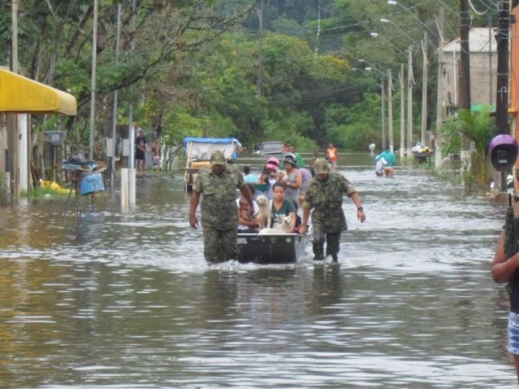
Isaiah 29:6 Thou shalt be visited of the LORD of hosts with thunder, and with earthquake, and great noise, with STORM and TEMPEST, and the flame of devouring fire.
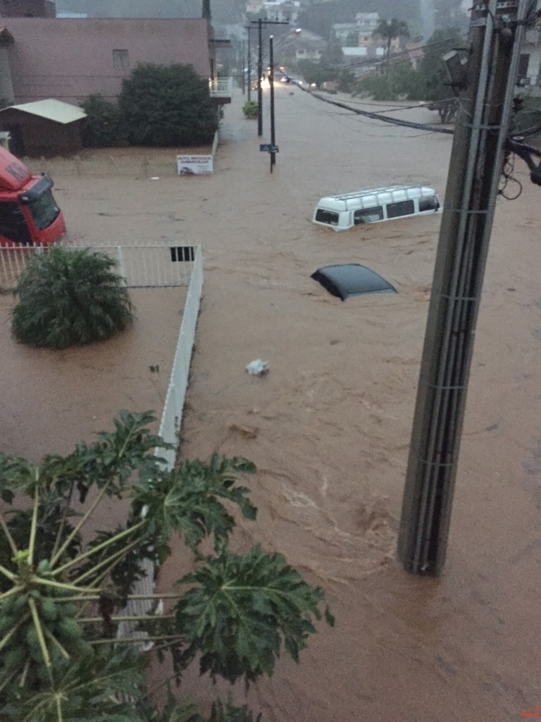
Jeremiah 10:11 Thus shall ye say unto them, The gods that have not made the heavens and the earth, even they shall perish from the earth, and from under these heavens.
[Brazilian witchcraft/Macumba and their idolatrous sacrifices in Candomblé, as well as in Catholicism, Christianity and other religions continue to anger the LORD, and cause His punishments/judgments.]
:12 He hath made the earth by his power, he hath established the world by his wisdom, and hath stretched out the heavens by his discretion.
:13 When he uttereth his voice, there is a multitude of WATERS in the heavens, and he causeth the vapours to ascend from the ends of the earth; he MAKETH LIGHTNINGS with RAIN, and bringeth forth the WIND out of his treasures.
Mass protests and upoars of the people in Brazil against corrupt government in 2016.


Isaiah 9:13 For the people turneth NOT unto him that smiteth them, neither do they seek the LORD of hosts.
Mass protests of the 2016 Olympics, and opposition government spending for temporary stadiums, and to make rich developers and builders more wealthy, while education, health care, and societal needs remain neglected.


2020 Floods and mudslides
Dozens of people have been killed and many more injured in torrential rain that hit the Brazilian states of Sao Paulo and Rio de Janeiro, triggering flash floods and destroying homes.
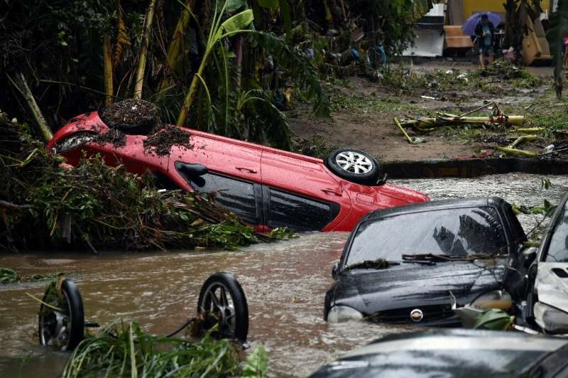
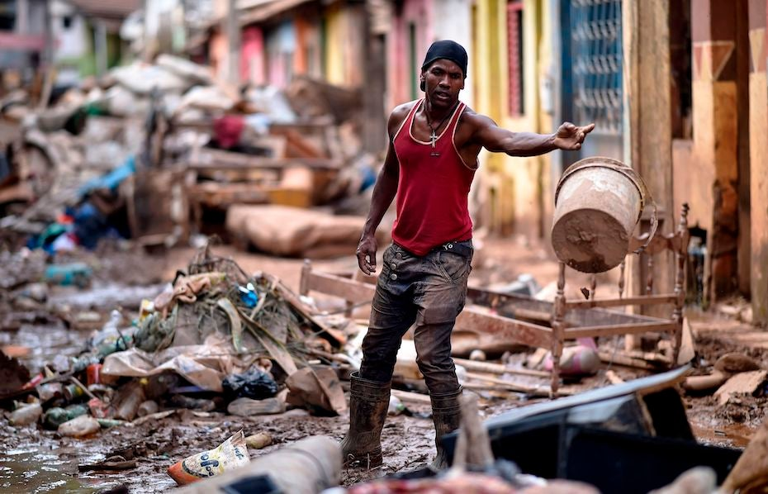

Mass graves at Parque Tarumã cemetery in Manaus, Brazil. COVID-19 update May 2020.
The coronavirus pandemic is killing black and Latino Americans at disproportionately high rates in the US [Babylon the Great]. This includes also indigenous brothers and sisters in Latin America [below].
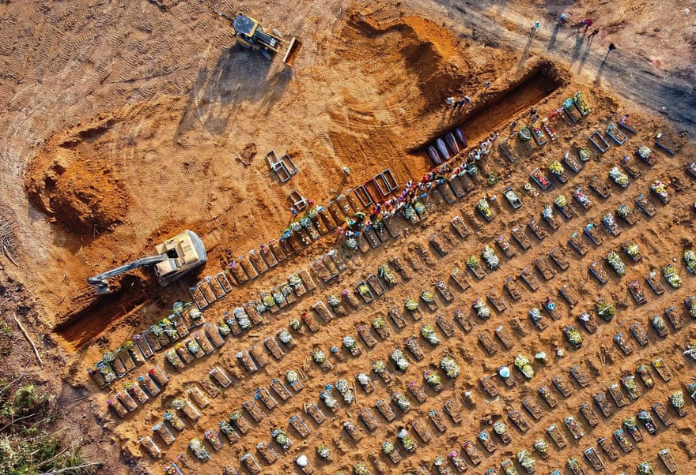
Deuteronomy 30:1 And it shall come to pass, when all these things are come upon thee, the blessing and the curse, which I have set before thee, and thou shalt call them to mind among all the nations, whither the LORD thy God hath driven thee,

:2 And shalt return unto the LORD thy God, and shalt obey his voice according to all that I command thee this day, thou and thy children, with all thine heart, and with all thy soul;

3 That then the LORD thy God will turn thy captivity, and have compassion upon thee, and will return and gather thee from all the nations, whither the LORD thy God hath scattered thee.

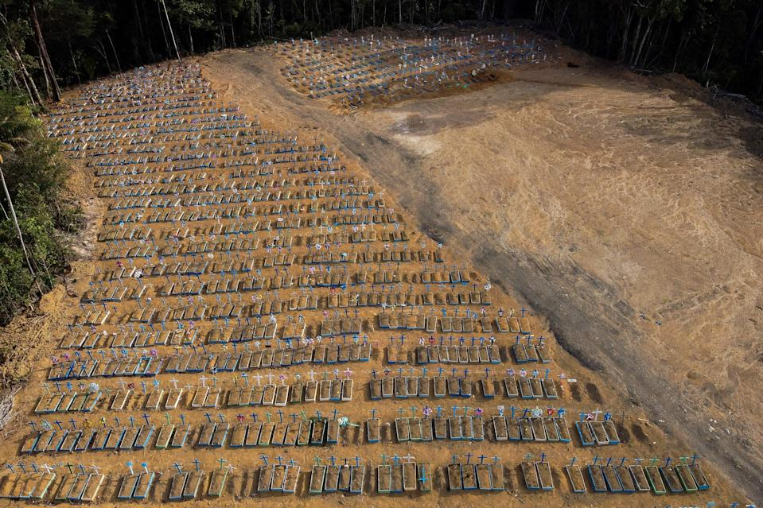

Wildfires in Brazil 2019-2021
The Amazon forest continues to be engulfed in flames. Aside from the perpetual deforestation already plaguing it. Fires in 2020 were 84% more than the fires in 2019. All of the 2021 fires are on land deforested in 2020, emphasizing the connection between deforestation and fires in the Brazilian Amazon.
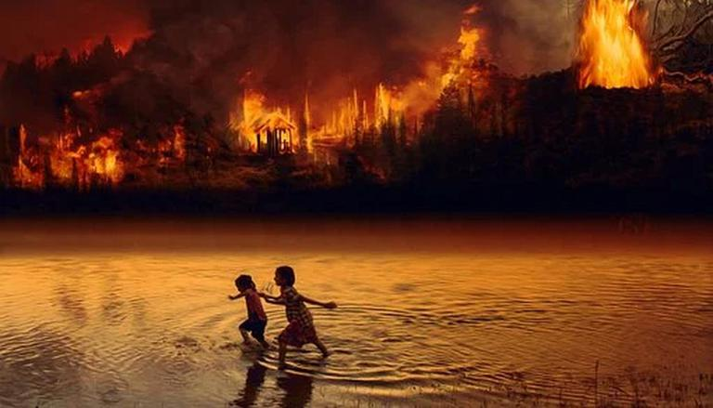Ecclesiasticus 39:29 FIRE, and hail, and famine, and death, all these were created for vengeance;
Millions of Brazilians have been diagnosed with the Covid-19 virus [pestilence], resulting in hundreds of thousands of deaths, which continues in 2021:
Psalms 91:1 He that dwelleth in the secret place of the most High shall abide under the shadow of the Almighty.
:2 I will say of the LORD, He is my refuge and my fortress: my God; in him will I trust.
:6 Nor for the PESTILENCE that walketh in darkness; nor for the destruction that wasteth at noonday.
:7 A thousand shall fall at thy side, and ten thousand at thy right hand; but it shall not come nigh thee.


Protests have erupted across dozens of cities in Brazil, June 3, 2021. Hundreds of thousands protest against President Jair Bolsonaro over his handling of the coronavirus pandemic.
IIEsdras 9:2 Then shalt thou understand, that it is the very same time, wherein the Highest will begin to visit the world which he made.
:3 Therefore when there shall be seen earthquakes and UPROARS of the people in the world:



Repent brethren of Brazil, while there is still time. The LORD’S Judgments and sufferings will only get worse and worse until Judgment Day, REPENT:
IIPeter 3:9 The Lord is not slack concerning his promise, as some men count slackness; but is longsuffering to us-ward, not willing that any should perish, but that all should come to repentance.
:10 But the day of the Lord will come as a thief in the night; in the which the heavens shall pass away with a great noise, and the elements shall melt with fervent heat, the earth also and the works that are therein shall be burned up.
:11 Seeing then that all these things shall be dissolved, what manner of persons ought ye to be in all holy conversation and godliness,
All honor glory and praises to our Almighty and Eternal Heavenly Father, through His Word our Life and King Jesus Christ.

1611 king james version bible/1769 king james version bible; www.thetruththebible.com

