Haiti, Repent

Haitian brothers and sisters, REPENT! Judgment Day is real. Look at the constant judgments and punishments God has brought to Haiti. These are not coincidences, bad luck, or mother nature! Obviously if Catholicism pleased God and was how to serve Him, or practising witchcraft/voodoo, He would not afflict Haiti with constant judgment, poverty, and despair:

Proverbs 28:13 He that covereth his sins shall not prosper: but whoso confesseth and forsaketh them shall have mercy.
But because lies and darkness continue to blind the whole earth, especially Haiti: Isaiah 60:1-2, IJohn 5:19, most of the people continue to follow this world's lies, wicked idolatries [Catholicism, Easter, Christmas, Christianity, etc.], and false ways to worship God. Including countless other evils because they are disguised and widely accepted. The Word/Bible only, which is also the true Jesus Christ, IS OUR LIFE [Deuteronomy 8:3, Psalms 40:7, John 6:63, etc.] NOT religions, NOT our own ways, nor doing what we think is best.
Redeem the time now, by using our last opportunity to REPENT and STOP THE SINS [breaking the commandments in the Bible: IJohn 3:4, Proverbs 13:13] that are being chosen with suffering, INSTEAD of what God says and commands us in the Bible:

IIPeter 3:9 The Lord is not slack concerning his promise, as some men count slackness; but is longsuffering to us-ward, not willing that any should perish, but that all should come to repentance.

:10 But the day of the Lord will come as a thief in the night; in the which the heavens shall pass away with a great noise, and the elements shall melt with fervent heat, the earth also and the works that are therein shall be burned up.

Luke 21:34 And take heed to yourselves, lest at any time your hearts be overcharged with surfeiting, and drunkenness, and cares of this life, and so that day come upon you unawares.
[surfeiting = indulging in sin completely: Proverbs 27:20;
drunkenness = totally consumed with idolatry: Deuteronomy 29:19]

:35 For as a snare shall it come on all them that dwell on the face of the whole earth.

2008

On August 26, 2008, the Most High’s Judgment, a Hurricane blasphemously called Gustav crosses the south peninsula, including the Sud and Grand'Anse départements, causing dozens of deaths and many disappearances, together with serious destruction of property. Thousands of families were affected by the storm, which destroyed and damaged thousands of houses. With 2 more hurricanes following this year.

Isaiah 29:6 Thou shalt be visited of the LORD of hosts with thunder, and with earthquake, and great noise, with STORM and TEMPEST, and the flame of devouring fire.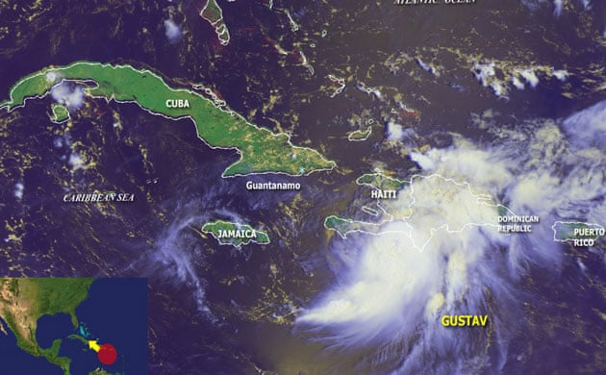

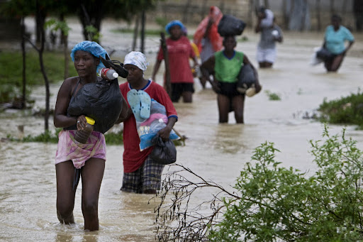

2010
On January 12, 2010 a magnitude 7.0 earthquake killed over 250,000 people with some estimates of the death toll even higher. Its epicentre was at approximately 25 km from Port-au-Prince, the capital. A dozen secondary shocks of magnitudes ranging from 5.0 to 5.9 were registered during the hours which followed. It was one of the deadliest earthquakes ever recorded.

Luke 21:11 And great EARTHQUAKES shall be in divers places, and famines, and PESTILENCES; and fearful sights and great signs shall there be from heaven.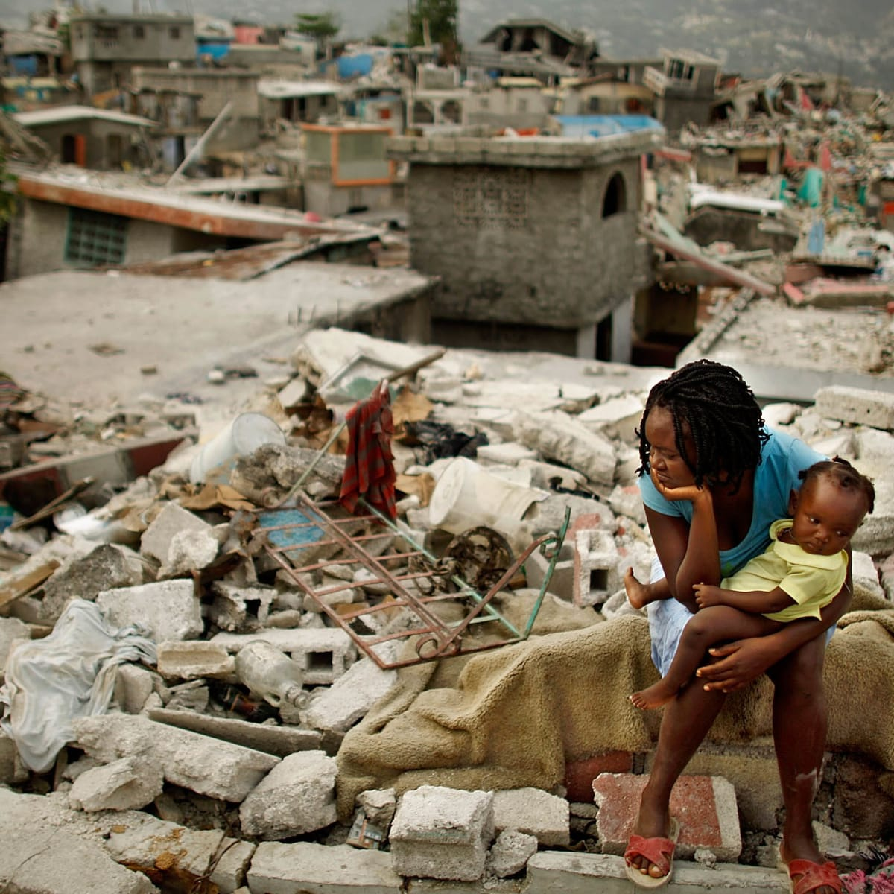

Jeremiah 5:22 Fear ye not me? saith the LORD: will ye not tremble at my presence, which have placed the sand for the bound of the sea by a perpetual decree, that it cannot pass it: and though the waves thereof toss themselves, yet can they not prevail; though they roar, yet can they not pass over it?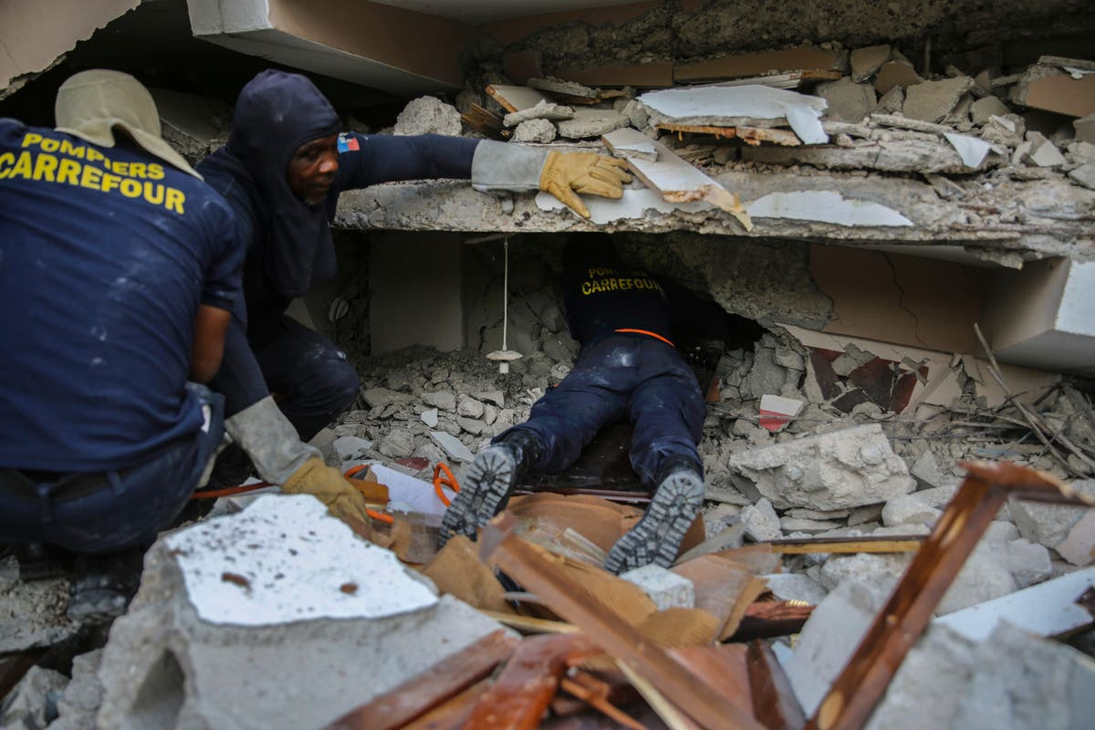

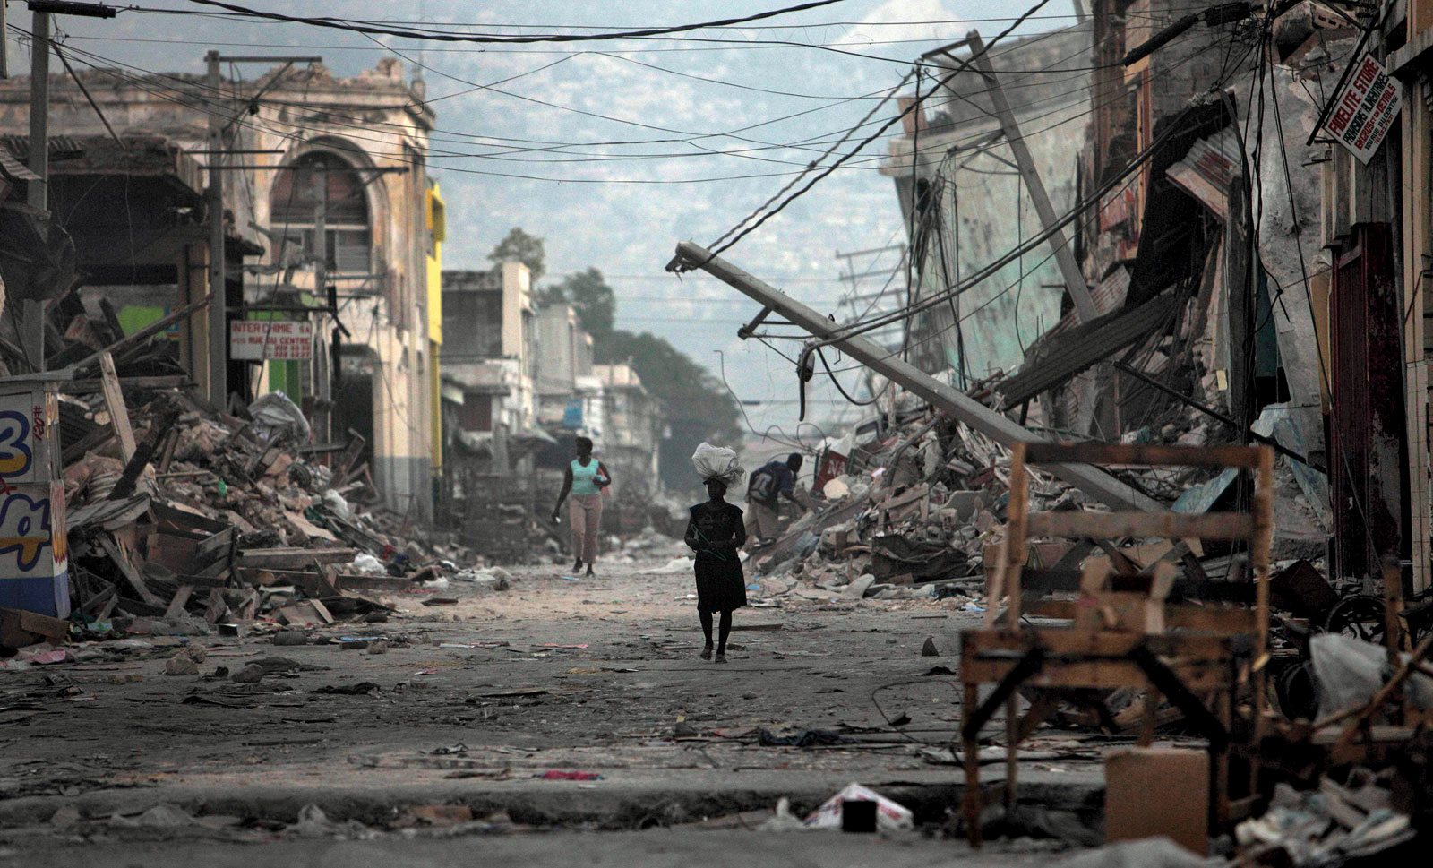

On October 20, 2010 a Cholera epidemic hit outside of Port-au-Prince, killing thousands of people and sickening hundreds of thousands.

Job 5:19 He shall deliver thee in six troubles: yea, in seven there shall no evil touch thee.

:20 In famine he shall redeem thee from death: and in war from the power of the sword.

:21 Thou shalt be hid from the scourge of the tongue: neither shalt thou be afraid of destruction when it cometh.

:22 At destruction and famine thou shalt laugh: neither shalt thou be afraid of the beasts of the earth.

:23 For thou shalt be in league with the stones of the field: and the beasts of the field shall be at peace with thee.
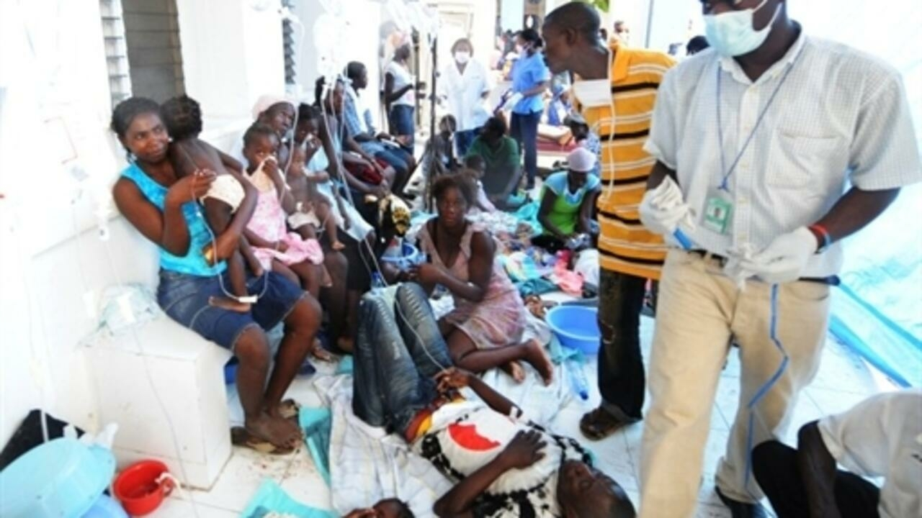

On November 5, 2010 a hurricane blasphemously called Tomas hits and kills several Haitians causing damage and worsening the cholera epidemic.

2012
On October 24, 2012 the Most High’s Judgment, a hurricane blasphemously called Sandy passes just west of Haiti, delivering heavy rainfall and leaving some areas with catastrophic flooding. Dozens of people were killed and many were left missing. Hundreds of people were left homeless as of October 29.

2016
On October 3-4, 2016 the Most High’s Judgment, a hurricane blasphemously called Matthew of the highest category 5, hits Jeremie, Haiti with catastrophic flooding of up to 40 inches and storm surge of up to 10 feet. Hunderds of people were killed and tens of thousands left homeless by the storm. [put in name of storm]
Isaiah 29:6 Thou shalt be visited of the LORD of hosts with thunder, and with earthquake, and great noise, with STORM and TEMPEST, and the flame of devouring fire.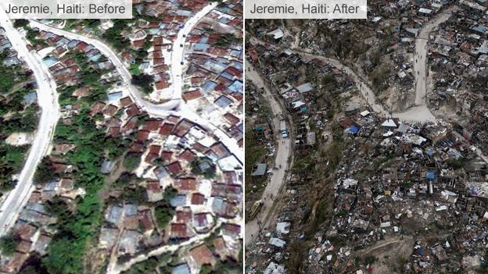

Matthew 24:21 For then shall be great tribulation, such as was not since the beginning of the world to this time, no, nor ever shall be.

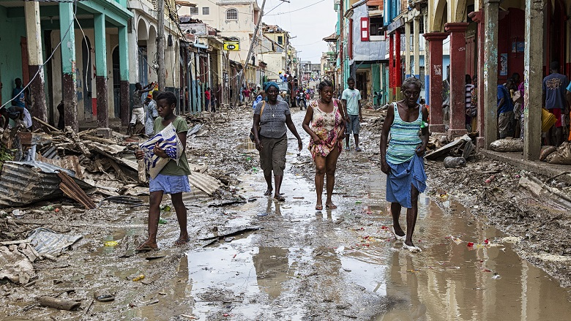

2018
On October 6, 2018 a 5.9 magnitude earthquake occurred at 20:11 local time killing dozens of people and injuring hundreds. Damage was mainly recorded in the far north of the island as stated by the Prime Minister Jean-Henry Céant.

Matthew 24:7 For nation shall rise against nation, and kingdom against kingdom: and there shall be famines, and pestilences, and EARTHQUAKES, in divers places.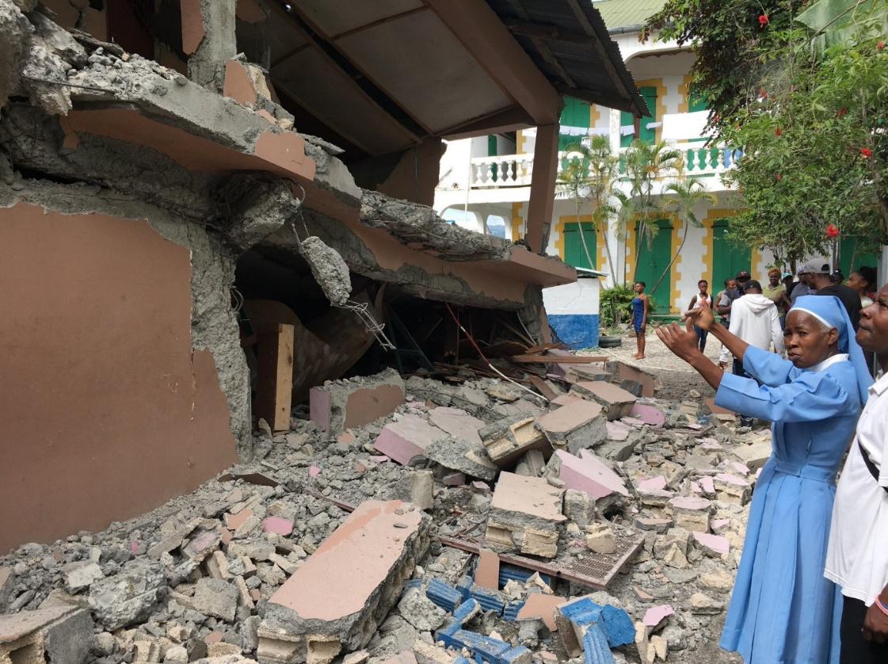

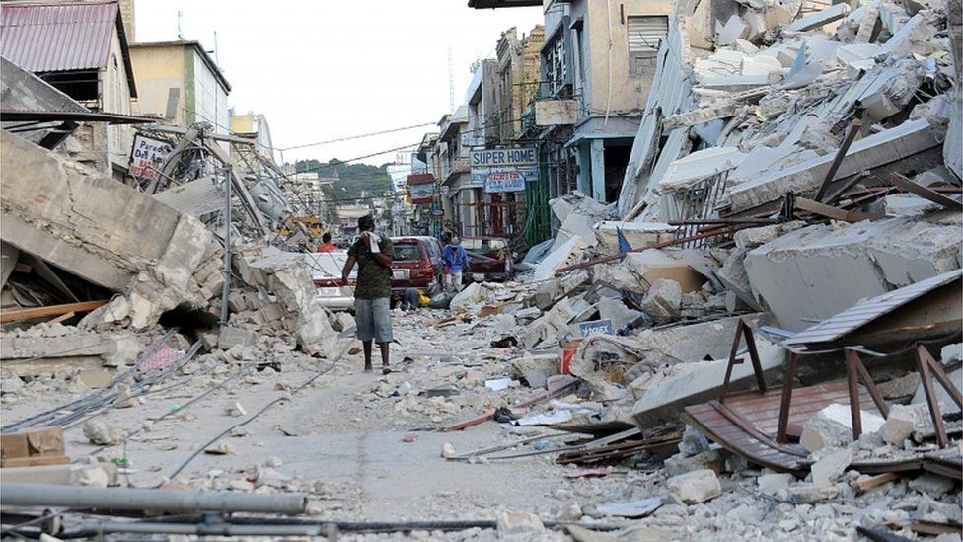

2020
On August 23, 2020 the Most High’s Judgment, a hurricane blasphemously called ‘Laura’ was a deadly and destructive Category 4 hurricane that was tied with the 1856 Last Island hurricane and it killed dozens of people in Haiti and several in the Dominican Republic.
Jeremiah 5:22 Fear ye not me? saith the LORD: will ye not tremble at my presence, which have placed the sand for the bound of the sea by a perpetual decree, that it cannot pass it: and though the waves thereof toss themselves, yet can they not prevail; though they roar, yet can they not pass over it?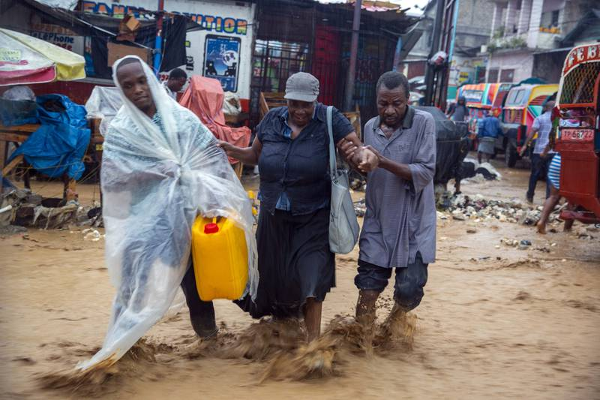

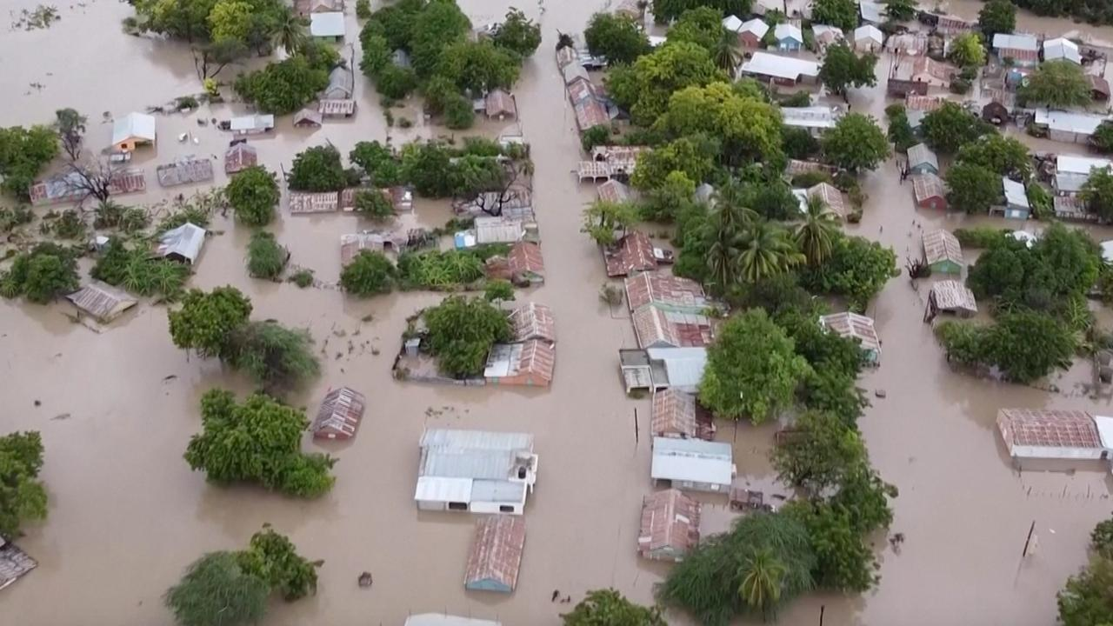

2021
On February 14, 2021 thousands of people have united in uproars and protests in the Haitian capital Port-au-Prince against President Jovenel Moise.

IIEsdras 9:2 Then shalt thou understand, that it is the very same time, wherein the Highest will begin to visit the world which he made.

:3 Therefore when there shall be seen earthquakes and UPROARS of the people in the world: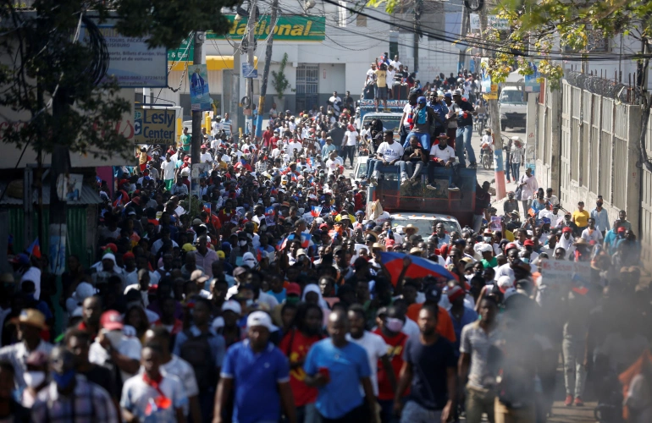



Haiti police clash with protesters.

Daniel 12:1 And at that time shall Michael stand up, the great prince which standeth for the children of thy people: and there shall be a TIME OF TROUBLE, such as never was since there was a nation even to that same time: and at that time thy people shall be delivered, every one that shall be found written in the book.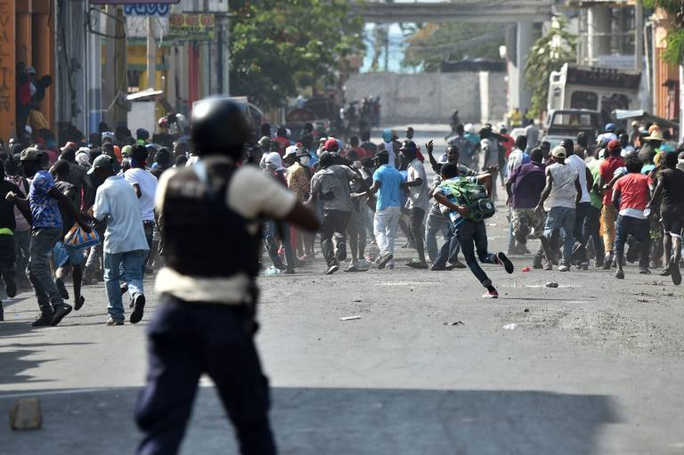

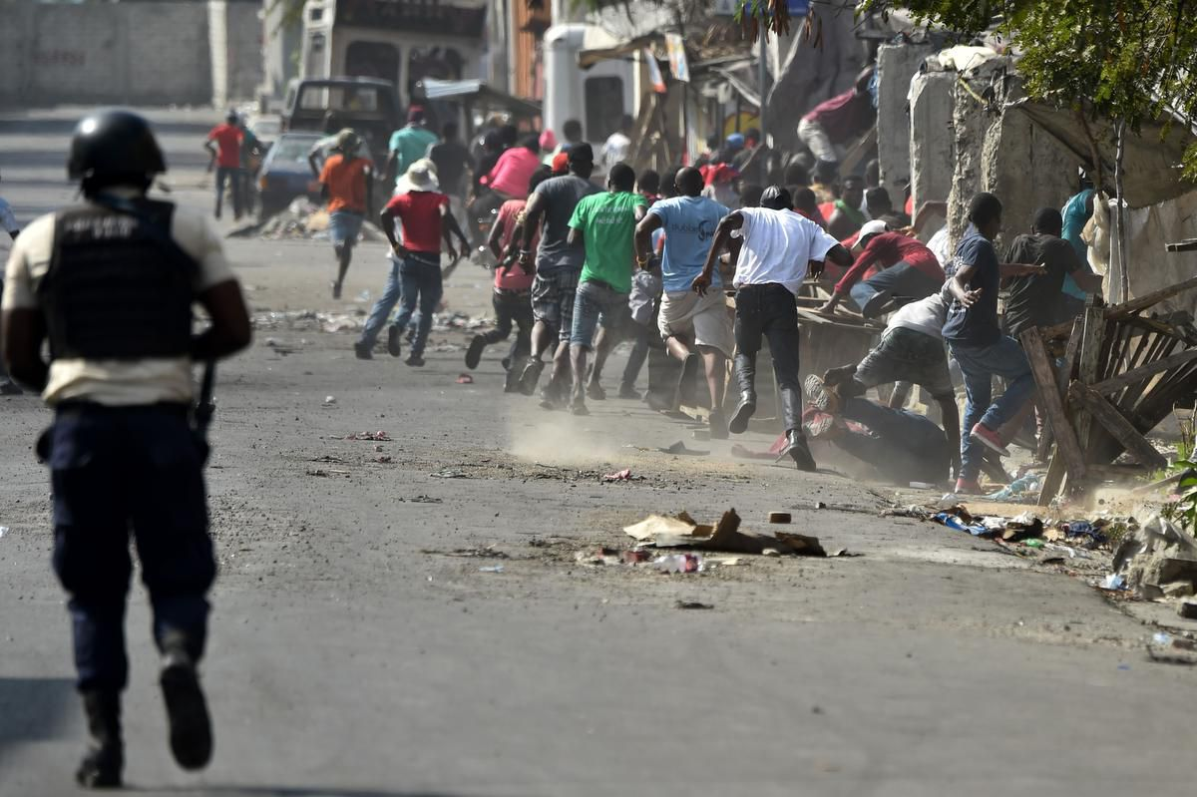

On May 24, 2021 the government declared a health emergency and imposed a curfew and safety measures due to a spike of COVID-19 cases.

Psalms 91:1 He that dwelleth in the secret place of the most High shall abide under the shadow of the Almighty.
:2 I will say of the LORD, He is my refuge and my fortress: my God; in him will I trust.
:6 Nor for the pestilence that walketh in darkness; nor for the destruction that wasteth at noonday.
:7 A thousand shall fall at thy side, and ten thousand at thy right hand; but it shall not come nigh thee.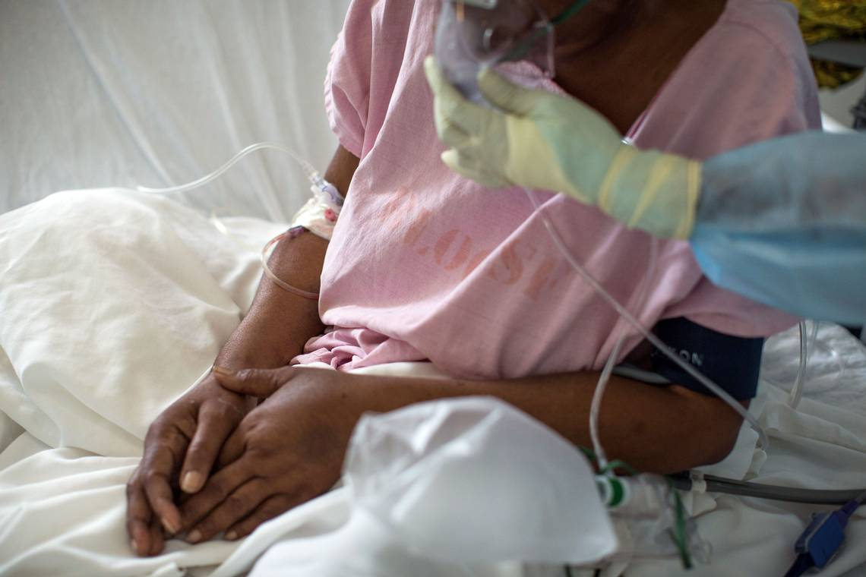

On August 14, 2021 a magnitude 7.2 earthquake struck Southwestern Haiti. It's epicenter was about
10 km from Petit-Trou-de-Nippes, approximately 150 km (93 miles) west of Port-au-Prince, the capital. The quake left behind significant damage. Tsunami warnings were immediately issued as several small tsunami waves struck surrounding areas. The death toll has risen to thousands, but is expected to grow. It is the strongest earthquake to strike Haiti since 1842.

IIEsdras 9:2 Then shalt thou understand, that it is the very same time, wherein the Highest will begin to VISIT the world which he made.

:3 Therefore when there shall be seen EARTHQUAKES and uproars of the people in the world: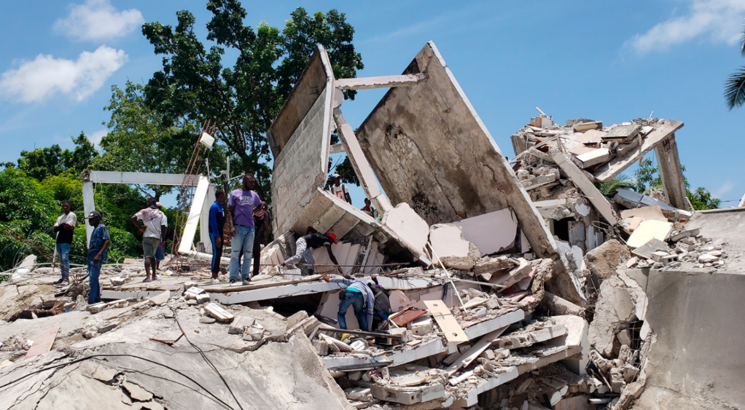

Luke 13:5 I tell you, Nay: but, except ye repent, ye shall all likewise perish.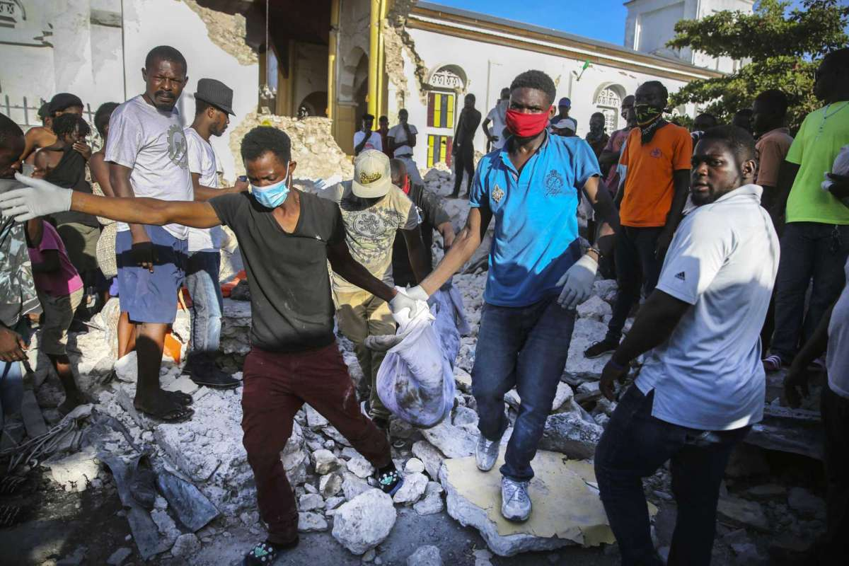

IITimothy 3:1 This know also, that in the last days PERILOUS TIMES shall come.
(perilous = exposed to imminent danger, extremely unsafe)

Repent my beloved brethren, we are in the Last Days:
Luke 13:5 I tell you, Nay: but, except ye repent, ye shall all likewise perish.

All honor glory and praises to our Almighty and Eternal Heavenly Father, and His Word our Life and King Jesus Christ.

1611 king james version bible/1769 king james version bible; www.thetruththebible.com

