Honduras, Repent
Honduran brothers and sisters, REPENT! Judgment Day is real. Look at the constant judgments and punishments God has brought upon Honduras. These are not coincidences, bad luck, nor mother nature! Obviously if Catholicism pleased God and was how to serve Him, or other religions and seeking to palm readers and other familar spirits and witchcraft, He would not afflict Honduras with constant judgment, poverty, and despair:

Proverbs 28:13 He that covereth his sins shall not prosper: but whoso confesseth and forsaketh them shall have mercy.
But because lies and darkness continue to blind the whole earth, especially Honduras: Isaiah 60:1-2, IJohn 5:19, most of the people continue to follow this world's lies, wicked idolatries [Catholicism, Easter, Christmas, Christianity, etc.], and false ways to worship God. Including countless other evils because they are disguised and widely accepted. The Word/Bible only, which is also the true Jesus Christ, IS OUR LIFE [Deuteronomy 8:3, Psalms 40:7, John 6:63, etc.] NOT religions, NOT our own ways, nor doing what we think is best.
Redeem the time now, by using our last opportunity to REPENT and STOP THE SINS [breaking the commandments in the Bible: IJohn 3:4, Proverbs 13:13] that are being chosen with suffering, INSTEAD of what God says and commands us in the Bible:

IIPeter 3:9 The Lord is not slack concerning his promise, as some men count slackness; but is longsuffering to us-ward, not willing that any should perish, but that all should come to repentance.

:10 But the day of the Lord will come as a thief in the night; in the which the heavens shall pass away with a great noise, and the elements shall melt with fervent heat, the earth also and the works that are therein shall be burned up.

Luke 21:34 And take heed to yourselves, lest at any time your hearts be overcharged with surfeiting, and drunkenness, and cares of this life, and so that day come upon you unawares.
[surfeiting = indulging in sin completely: Proverbs 27:20;
drunkenness = totally consumed with idolatry: Deuteronomy 29:19]

:35 For as a snare shall it come on all them that dwell on the face of the whole earth.

TURN TO the Heavenly Father by obeying His Word/Jesus Christ [The bible]:
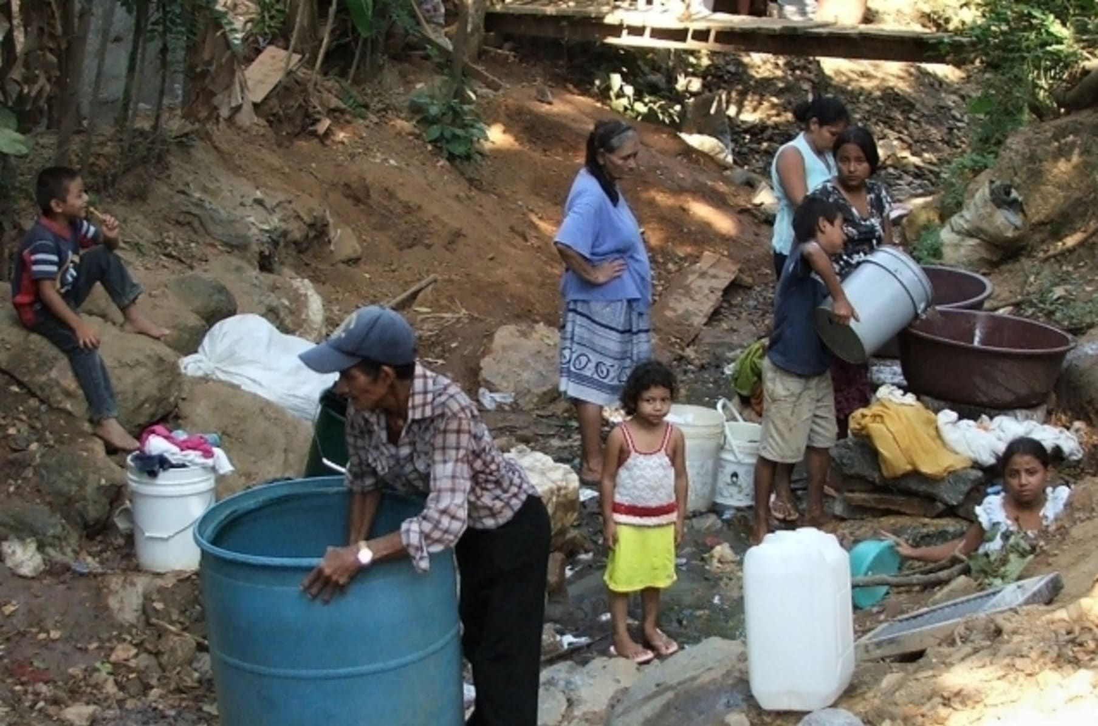
2019

Throughout Honduras, and especially in the capital Tegucigalpa, murders by criminal gangs are a major issue.
According to the Honduran police, 2,322 murders were registered as of mid-August 2019, and in the same period of 2020 there were 1,934, in a population of approximately 10.1 million inhabitants. And the violence and killing continues even to this day.

Psalms 55:23 But thou, O God, shalt bring them down into the pit of destruction: BLOODY and deceitful men shall not live out half their days; but I will trust in thee.

2020
The corona pandemic hit Honduras hard, where most people were already struggling with poverty, unemployment and housing shortage even without corona.

Matthew 24:3 And as he sat upon the mount of Olives, the disciples came unto him privately, saying, Tell us, when shall these things be? and what shall be the sign of thy coming, and of the end of the world?
:7 For nation shall rise against nation, and kingdom against kingdom: and there shall be famines, and PESTILENCES, and earthquakes, in divers places.
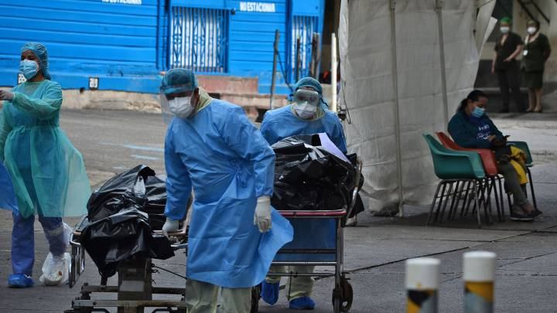
By repenting truly [obeying the LORD’S commandments in the Bible], the LORD will protect His children, the true Israelites which include so-called Hondurans. While His judgments, pestilences and punishments will continue in Honduras and in the earth, the LORD will protect those that abide in Him and His Word [the true Jesus Christ]:
Psalms 91:1 He that dwelleth in the secret place of the most High shall abide under the shadow of the Almighty.
:2 I will say of the LORD, He is my refuge and my fortress: my God; in him will I trust.

:6 Nor for the pestilence that walketh in darkness; nor for the destruction that wasteth at noonday.
:7 A thousand shall fall at thy side, and ten thousand at thy right hand; but it shall not come nigh thee.

2020
Between 3 and 17 November 2020, both blasphemously called hurricane Eta and Iota were of a high devastating category and are the LORD’S judgment. Heavy rainfall led to deadly flash flooding and landslides displacing hundreds of thousands of people, and killing hundreds. With an overall economic toll of $1 billion.
Deuteronomy 8:5 Thou shalt also consider in thine heart, that, as a man chasteneth his son, so the LORD thy God chasteneth thee.
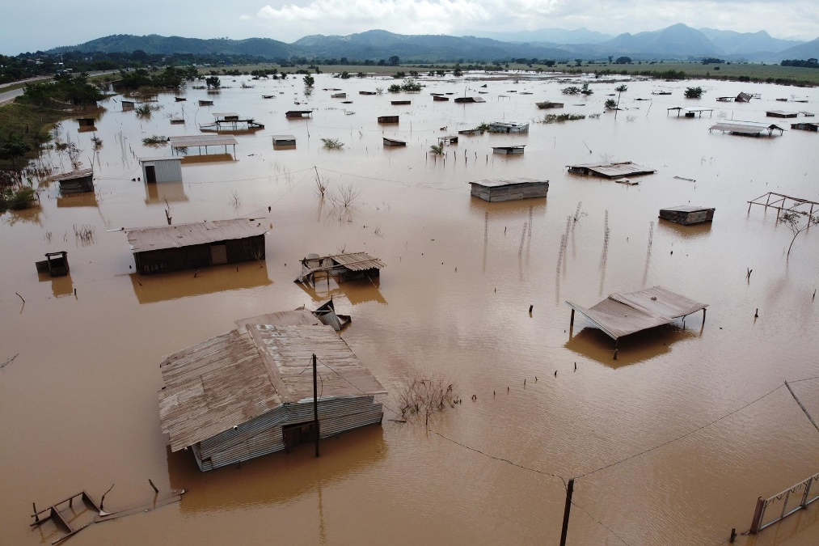

The pandemic is stopping people recovering from these hurricanes and due to hundreds of thousands being displaced the majority are now living under miserable conditions such as on the streets and living underneath bridges. And their only income being a few dollars a day by begging.

Isaiah 29:6 Thou shalt be visited of the LORD of hosts with thunder, and with earthquake, and great noise, with STORM and TEMPEST, and the flame of devouring fire.
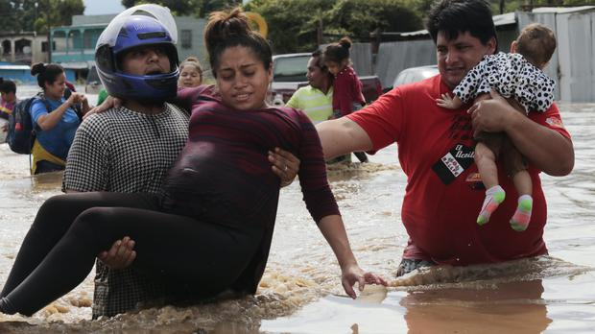

On January 17, 2021, Guatemalan security forces beat back caravan of Honduran migrants.

The Most High’s judgments through storms, earthquakes, hurricanes, etc., the effect of the pandemic as well as corruption, insecurity and poverty; along with NOT YET knowing the Bible and widespread lies and deceits from Babylon the Great/America continue to drive mass migration and have many risking life and health to start a new life in Satan's headquarters [America] in these last days:
Revelation 13:3 And I saw one of his heads as it were wounded to death; and his deadly wound was healed: and all the world wondered after the beast.
:4 And they worshipped the dragon which gave power unto the beast: and they worshipped the beast, saying, Who is like unto the beast? who is able to make war with him?
Honduran migrant caravan numbered at 4,000 and rising, heading to U.S. border crossing before violent resistence by Guatemala armed forced.

Proverbs 29:2 When the righteous are in authority, the people rejoice: but when the wicked beareth rule, the people MOURN.
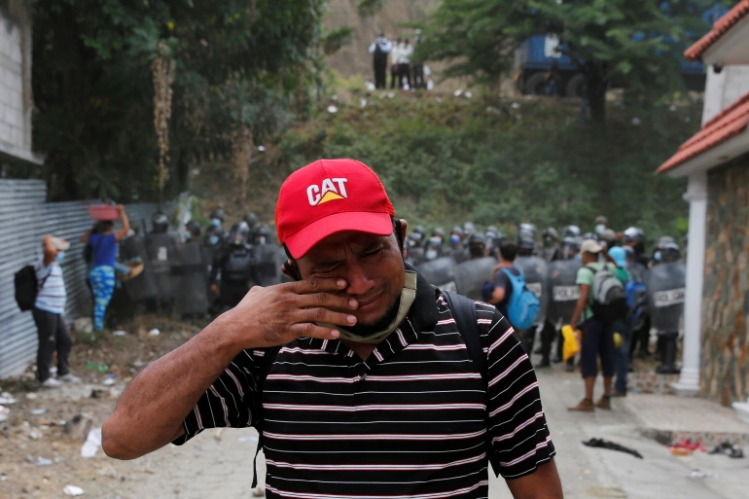
Isaiah 9:13 For the people turneth not unto him that smiteth them, neither do they seek the LORD of hosts.
Guatemala armed forces attacking migrants from Honduras wondering after the beast en route to Babylon the Great [The United States of America]. Rather than seeking the LORD truly!
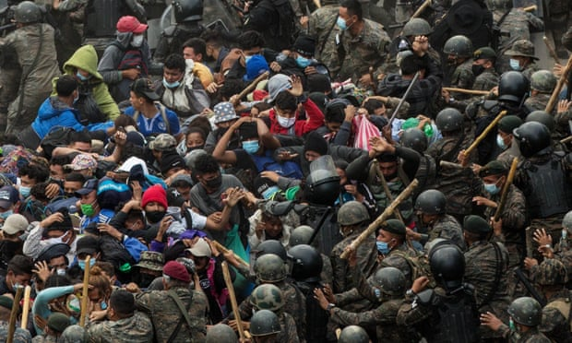

“We have no work. We can’t go back,” one member insisted. “Back home we’re dying of hunger.”
Daniel 12:1 And at that time shall Michael stand up, the great prince which standeth for the children of thy people: and there shall be a TIME OF TROUBLE, such as never was since there was a nation even to that same time: and at that time thy people shall be delivered, every one that shall be found written in the book.
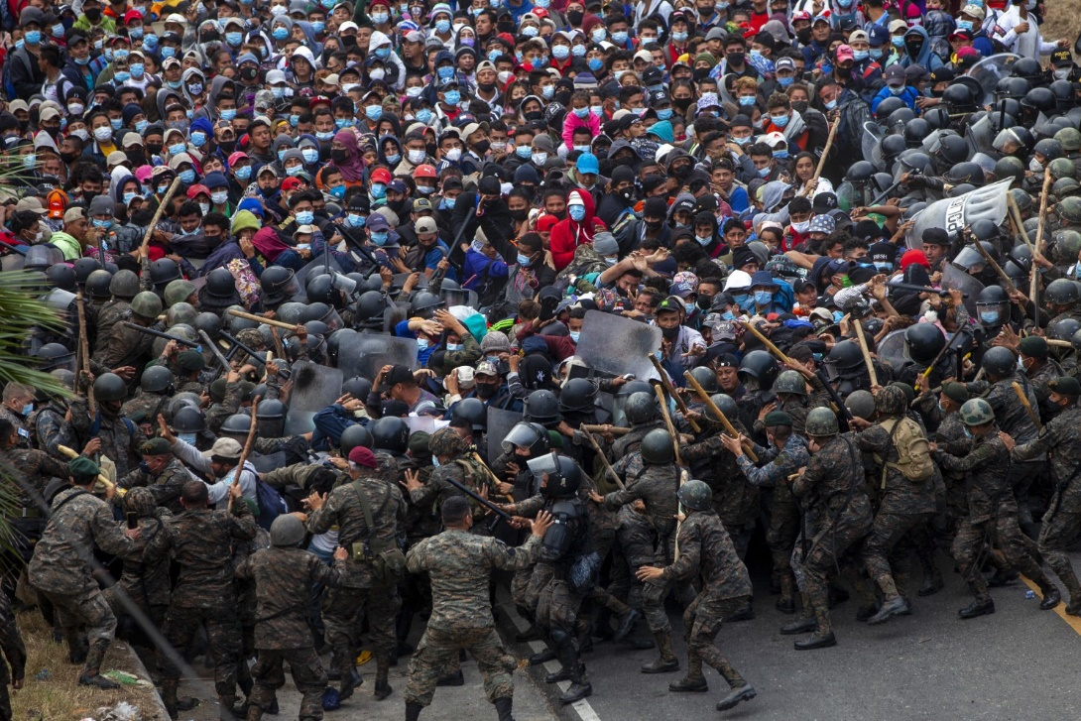
IITimothy 3:1 This know also, that in the last days PERILOUS TIMES shall come.
(perilous = exposed to imminent danger, extremely unsafe)

Repent my beloved brethren, we are in the Last Days:
Luke 13:5 I tell you, Nay: but, except ye repent, ye shall all likewise perish.

All honor glory and praises to our Almighty and Eternal Heavenly Father, and His Word our Life and King Jesus Christ.

1611 king james version bible/1769 king james version bible; www.thetruththebible.com
www.laverdadlabiblia.com

